**Domain:** Book Publishing Company.

**Objective:** To select/create a domain and to define the entities, attributes and relations and to create a Relational Schema and an Entity Relation Diagram

**Requirement:** A publishing company produces books on various subjects. The books are written by authors who are specialized in one particular subject. The company employs editors who, not necessarily being specialist in a particular area, each take sole responsibility for editing one or more book or more publications. Every book requires some item for publications. These items are supplied by suppliers. One supplier can supply many items. Shop owner buys books from publisher. Shop owner can buy many books but one book can only be bought by one shop owner only. Books are uniquely identified by Book ID.

**Entities:**

* + - * Publisher
      * Books
      * Editor
      * Supplier
      * Item
      * Shop Owner
      * Author
      * Subject

**Attributes:**

* + - * Book- Book ID, Book Name.
      * Author- Author ID, Author Name.
      * Item- Item ID.
      * Supplier- Supplier ID.

**Relationships:**

* + - * One Publisher publishes many books.
      * One subject has many books.
      * Many authors are specialized in one subject.
      * Many authors have written many books.
      * One editor edits many books.
      * One shop owner can buy many books.
      * Many suppliers supply many items.
      * Many books require many items.

**ER Diagram:** 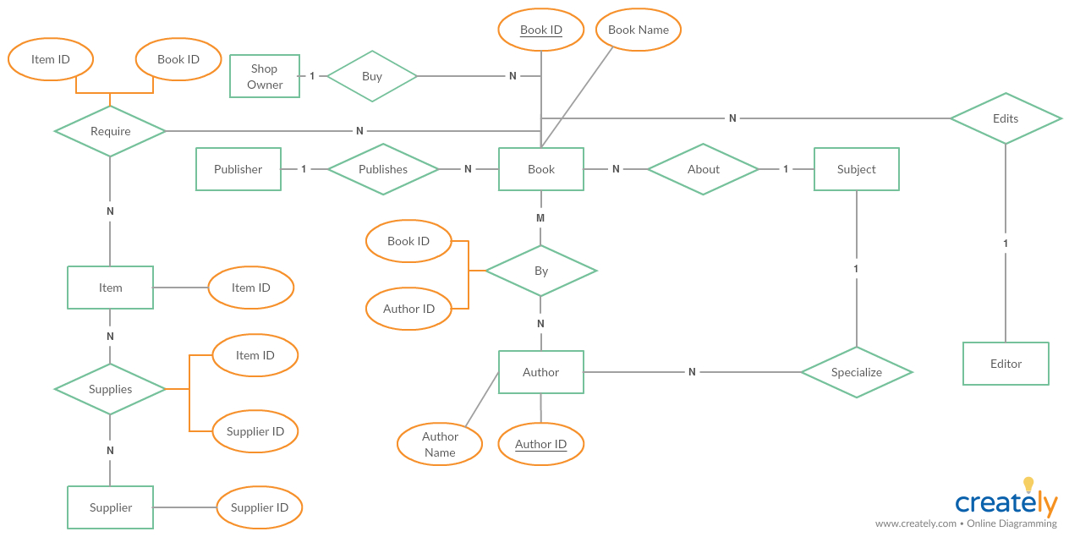

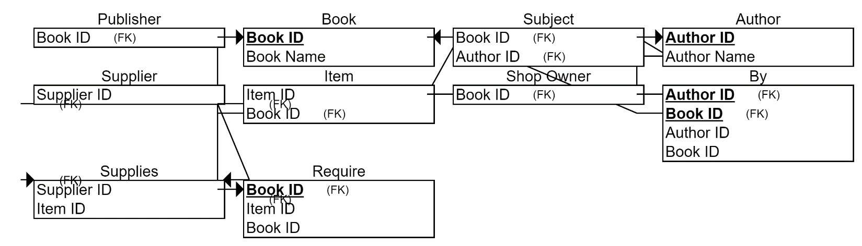**Relational Schema:**